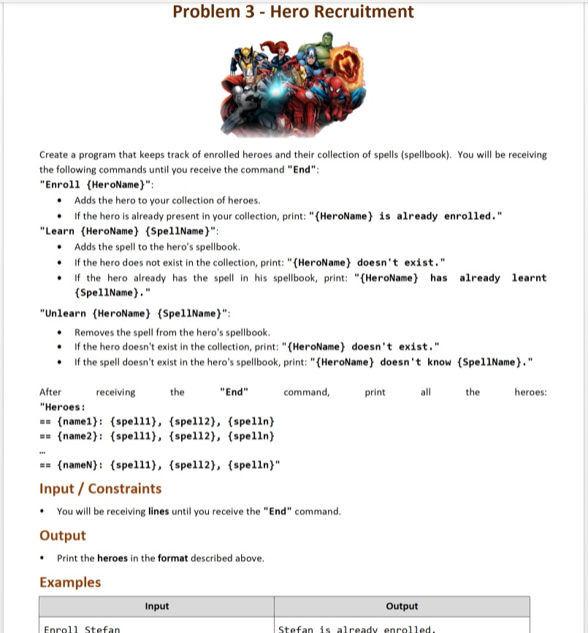

### Input

* The **possible** commands are:
  + **"End"**
  + **"Enroll {HeroName}"**
  + **"Learn {HeroName} {SpellName}"**
  + **"Unlearn {HeroName} {SpellName}"**

### Output

* The **possible** outputs are:
* **"{HeroName} is already enrolled."**
* "**{HeroName} doesn't exist."**
  + "{HeroName} has already learnt {SpellName}."
* **"{HeroName} doesn't know {SpellName}."**
  + **"Heroes:**

**== {name1}: {spell1}, {spell2}, {spelln}**

**== {name2}: {spell1}, {spell2}, {spelln}**

**…**

**== {nameN}: {spell1}, {spell2}, {spelln}"**

### Examples

|  |  |
| --- | --- |
| **Input** | **Output** |
| Enroll Stefan  Enroll Peter  Enroll Stefan  Learn Stefan ItShouldWork  Learn John ItShouldNotWork  Unlearn George Dispel  Unlearn Stefan ItShouldWork  End | Stefan is already enrolled.  John doesn't exist.  George doesn't exist.  Heroes:  == Stefan:  == Peter: |
| **Input** | **Output** |
| Enroll Stefan  Learn Stefan ItShouldWork  Learn Stefan ItShouldWork  Unlearn Stefan NotFound  End | Stefan has already learnt ItShouldWork.  Stefan doesn't know NotFound.  Heroes:  == Stefan: ItShouldWork |
| **Input** | **Output** |
| Enroll Stefan  Enroll Peter  Enroll John  Learn Stefan Spell  Learn Peter Dispel  End | Heroes:  == Stefan: Spell  == Peter: Dispel  == John: |

### JS Examples

The input will be provided as an array of strings.

|  |  |
| --- | --- |
| **Input** | **Output** |
| (["Enroll Stefan",  "Enroll Peter",  "Enroll Stefan",  "Learn Stefan ItShouldWork",  "Learn John ItShouldNotWork",  "Unlearn George Dispel",  "Unlearn Stefan ItShouldWork",  "End"]) | Stefan is already enrolled.  John doesn't exist.  George doesn't exist.  Heroes:  == Stefan:  == Peter: |
| **Input** | **Output** |
| (["Enroll Stefan",  "Learn Stefan ItShouldWork",  "Learn Stefan ItShouldWork",  "Unlearn Stefan NotFound",  "End"]) | Stefan has already learnt ItShouldWork.  Stefan doesn't know NotFound.  Heroes:  == Stefan: ItShouldWork |
| **Input** | **Output** |
| (["Enroll Stefan",  "Enroll Peter",  "Enroll John",  "Learn Stefan Spell",  "Learn Peter Dispel",  "End"]) | Heroes:  == Stefan: Spell  == Peter: Dispel  == John: |